

Express. Create. Inspire.

Course Project Phase 1
CMPS350: Web Development Fundamentals
Spring 2026
Dr. Mucahid Kutlu
Section - L52

Hanin M. Said 202104168
Mahajuba Rahman 202311830
Ashley Danoy 202304384
Jawairia Ahmed 202208287

Table of Contents
I. Project Overview 3
II. Features Check List 4
III. Quick Guide 4
IV. Project Links 7

Project Overview
Creativo is a web-based platform designed to bring creative individuals together in one simple, interactive space. The idea behind the project is to provide users with a place where they can share their thoughts, ideas, and creative content, whether it is poetry, short stories, art concepts, or even simple prompts for inspiration.
The platform is built with a focus on simplicity and usability. Users can create an account, log in securely, and start posting content immediately. Each user has their own identity within the system, and their contributions become part of a shared feed where others can explore and engage with different forms of creativity.
From a functional perspective, the system handles user authentication, content creation, and data persistence using local storage. This allows the application to simulate a real-world social platform experience without relying on a backend server. Once a user registers, their data is stored and used for future login sessions, ensuring continuity and a personalized experience.
The design of Creativo also plays an important role. The interface follows a clean and modern aesthetic, with a consistent color palette and typography that reflects a creative and expressive environment. The goal was not only to make the system functional, but also visually appealing and comfortable to use.
Overall, this project demonstrates the integration of front-end web development concepts, including HTML structure, CSS styling, and JavaScript functionality. It focuses on creating a complete user experience, starting from authentication and extending to content interaction, while maintaining a balance between design and technical implementation.

Features Check List

Feature | Status | Notes
User Registration | Implemented | Users can create an account with username, email, and password with validation
User Login | Implemented | Login verifies credentials and redirects to feed
User Logout | Implemented | Logout button clears session and returns to login
Local Storage Persistence | Implemented | Users and posts are stored using browser localStorage
Create Post | Implemented | Users can create posts (max 200 characters) with categories
View Feed | Implemented | Displays posts dynamically on the main feed page
Explore Feed | Implemented | Users can switch between personal feed and explore all posts
Category Filtering | Implemented | Posts can be filtered by categories (poetry, story, etc.)
Search Users | Implemented | UI exists but functionality it is still limited
Profile Page | Implemented | Displays user info, posts, and stats
Edit Profile | Implemented | Users can edit username, bio, and avatar
Follow System | Partially Implemented | UI present but logic may is not fully functional
Delete Post | Implemented | Users can delete their own posts, which are removed from the feed and local storage.
Edit Post | Not Implemented | Not included due to time constraints

Quick Guide

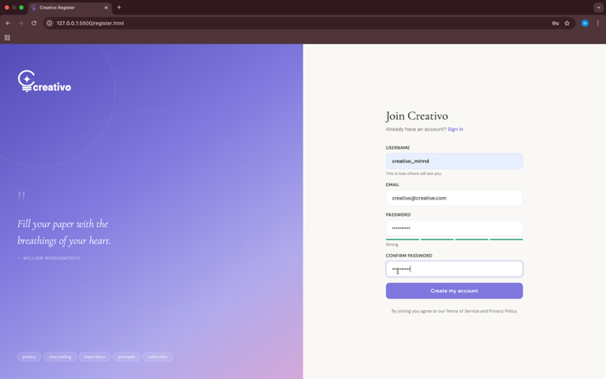
Using Creativo is designed to be simple and straightforward. The user journey starts from account creation and continues into exploring and sharing content.
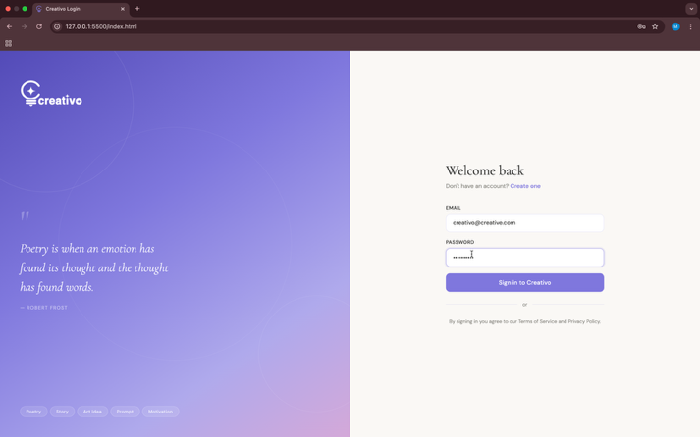
First, the user opens the application and is presented with the login page. If they do not have an account, they can navigate to the registration page and create a new account by entering a username, email, and password. Once the account is created, the user can log in using their credentials.

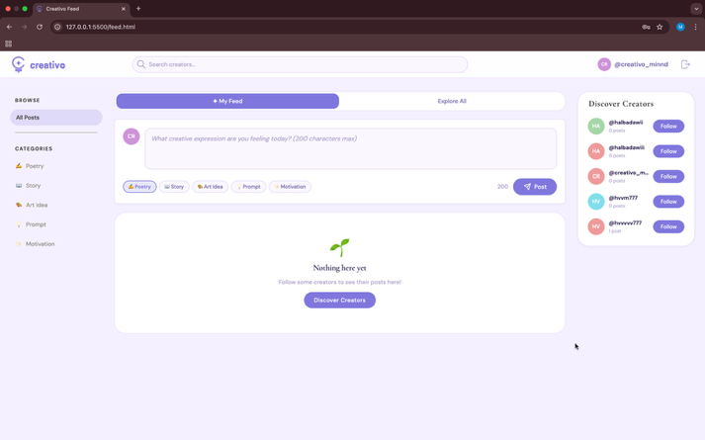
After logging in, the user is redirected to the main feed page. This is where most of the interaction happens. The user can write a post, select a category, and publish it directly to the feed. Posts appear instantly, creating a smooth and responsive experience.

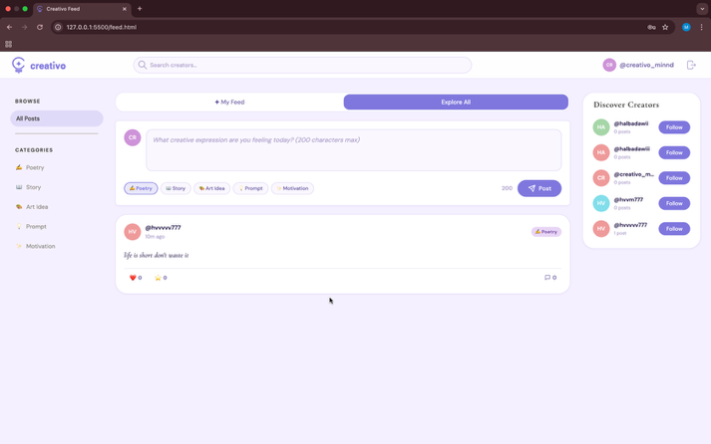
The feed allows users to switch between their personalized content and exploring posts from other users. Categories can also be used to filter posts based on interest.
Users can access their profile through the navigation bar. The profile page displays their information, including username, bio, and posts. They can also edit their profile details such as bio and profile picture.
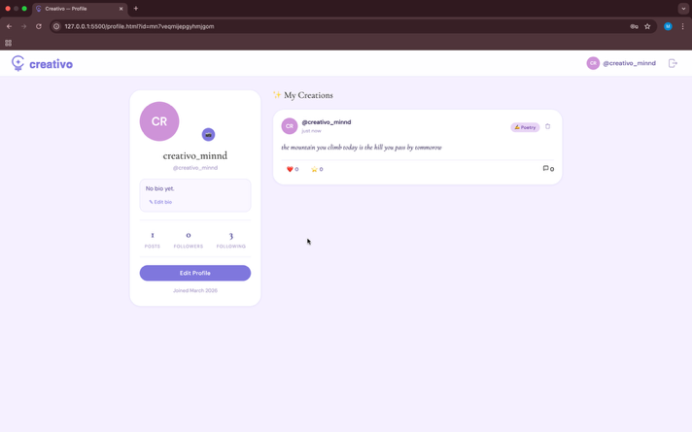

Finally, the user can log out at any time using the logout button in the navigation bar.
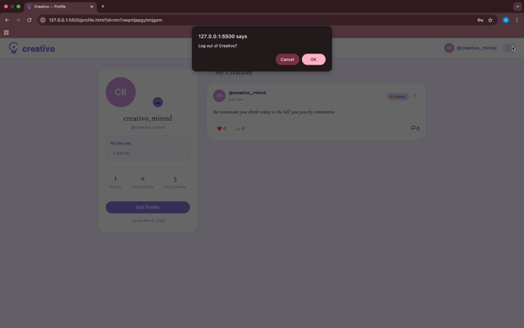

Project Links

- GitHub Repository: https://github.com/hr2104168/creativo.git
- Live Demo URL: https://hr2104168.github.io/creativo/

